* **Foreign Keys & Index have ()**
* **Joins have a period .**
* **LEFT JOIN 2ndtable ON 1stTable.MatchingColumn=2ndTable.MatchingColumn;**
* **CHANGE COLUMN Year ReleaseYear SMALLINT;**
* **Creating table - FOREIGN KEY (RatingCode) REFERENCES Rating (RatingCode));**
* **Altering table - ALTER TABLE Movie** 
  + - **ADD CONSTRAINT Year**
    - **FOREIGN KEY (Year) REFERENCES YearStats(Year);**

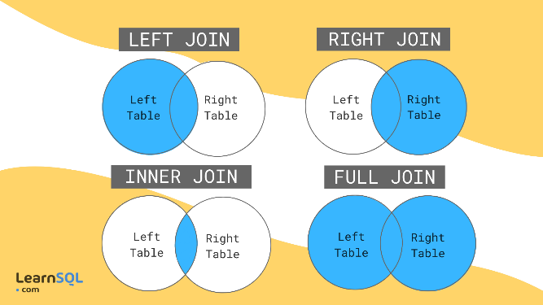

**-- Your SQL goes here**

CREATE TABLE Movie (

Title VARCHAR(30),

RatingCode VARCHAR(5),

FOREIGN KEY (RatingCode) REFERENCES Rating (RatingCode)

);

**-- Your SQL goes here**

ALTER TABLE Movie

ADD CONSTRAINT Year

FOREIGN KEY (Year) REFERENCES YearStats(Year);

**-- Your SQL goes here**

SELECT Movie.Title, YearStats.TotalGross

FROM Movie

LEFT JOIN YearStats ON Movie.Year = YearStats.Year;